Batch: A1 Roll No.: 16010123012
Experiment / Assignment / Tutorial No.: 07

Title: Implementation of CNN Deep Learning Architecture

Aim: To understand & implement CNN using python.
Expected Outcome of Experiment:
CO4:

Books/ Journals/ Websites referred:
- “Deep Learning Core Concepts, Methods and Applications”, M. Gopal, Pearson, 2022.
- https://www.geeksforgeeks.org/machine-learning/introduction-convolution-neural-network/
- https://medium.com/

Theory of Convolutional Neural Networks (CNNs):

Convolutional Neural Networks (CNNs), also known as ConvNets, are neural network architectures inspired by the human visual system and are widely used in computer vision tasks. They are designed to process structured grid-like data, especially images by capturing spatial relationships between pixels. CNN for classification task has two kinds of layers; one deals with feature engineering, and other performs classification. The feature engineering layers are called convolution layers and the classification layers are called convolutional layers.
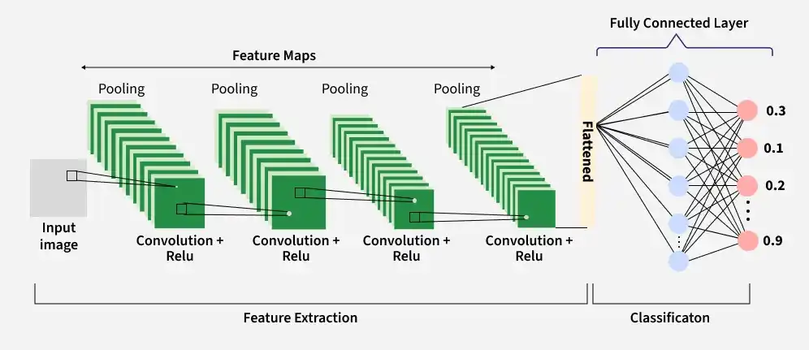

Key Components of CNN
A complete Convolution Neural Networks architecture also known as covnets is a sequence of layers and every layer transforms one volume to another through a differentiable function.

1. Input Layer
The input layer receives the raw image data and passes it to the network for processing. In CNNs, input is typically a 3D volume (width × height × depth). This layer stores pixel values of the image (e.g., 32 × 32 × 3 for RGB images); preserves the spatial structure of the image for further feature extraction.

2. Convolutional Layers
Convolution layers are key building blocks of convolutional neural networks (CNNs) that are responsible for extracting important features from the input data. They apply convolution operation to the input data which involves a set of learnable filters (kernels) that slide over the image and compute the dot product between the filter weights and corresponding image patches, producing feature maps. Uses small filters (e.g., 2×2, 3×3, 5×5) to scan the input image. This process allows the network to detect patterns such as edges, textures and shapes in the input images. E.g. Using 12 filters results in an output volume of 32 × 32 × 12.
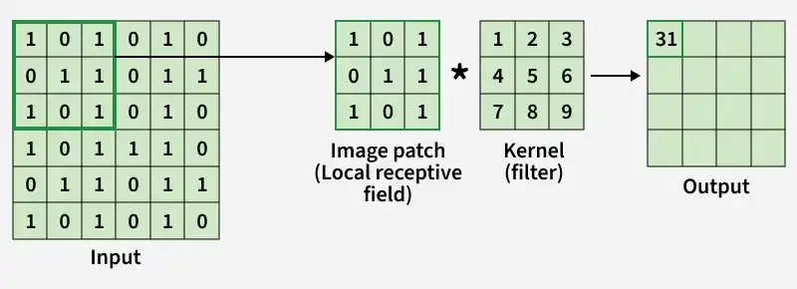

Components of a Convolution Layer

Filters (Kernels): Small matrices that extract specific features from the input. For example, one filter might detect horizontal edges while another detects vertical edges. The values of filters are learned and updated during training.

Stride: Refers to the step size with which the filter moves across the input data. Larger strides result in smaller output feature maps and faster computation.

Padding: Zeros or other values may be added around the input to control the spatial dimensions of the output.

Common types: "valid" (no padding) and "same" (pads output so feature map dimensions match input).

Mathematical Representation:
For 2-D input image, using 2-D kernel (filter) the convolution operation can be represented in the following form:
J (x, y) = I * K (x, y) = ∑_{i} ∑_{j} I (i, j) K (x-i, y-j)
where, I represents 2-D input image; K is the 2-D kernel/filter
The feature maps in first convolution layer C¹ can be mathematically written as:
C¹_{j} = σ ((X * K¹_{1,j}) + b¹_{j} = σ (a_{j})
where,
K¹_{1,j} denotes elements of first layer kernel
(i, j ) indices denotes the indices of the current and next feature map (here i = 1)
σ (.) us the non linear activation function, and a_{j} is the activation value; j= 1, 2
The operation * denotes 2 D convolution.
3. Activation Layer:
The Activation Layer introduces non-linearity into the network by applying an element-wise activation function to the output of the convolution layer. After convolution, a non-linear function is often applied allowing the network to learn complex relationships in data beyond linear relationships. The output dimensions remain unchanged (e.g., 32 × 32 × 12). Common activation functions: ReLU, Sigmoid, tanh, Leaky ReLU etc.
4. Pooling Layer
Pooling (Optional): The Pooling Layer is used to reduce the spatial dimensions of the feature maps and retain the most important information. This makes computation faster, reducing memory usage and helping to prevent overfitting. It is typically inserted between convolutional layers in a CNN. Pooling reduces width and height while keeping depth unchanged. Common types include Max Pooling and Average Pooling. Example: Using 2 × 2 max pooling with stride 2 reduces the volume from 32 × 32 × 12 to 16 × 16 × 12.
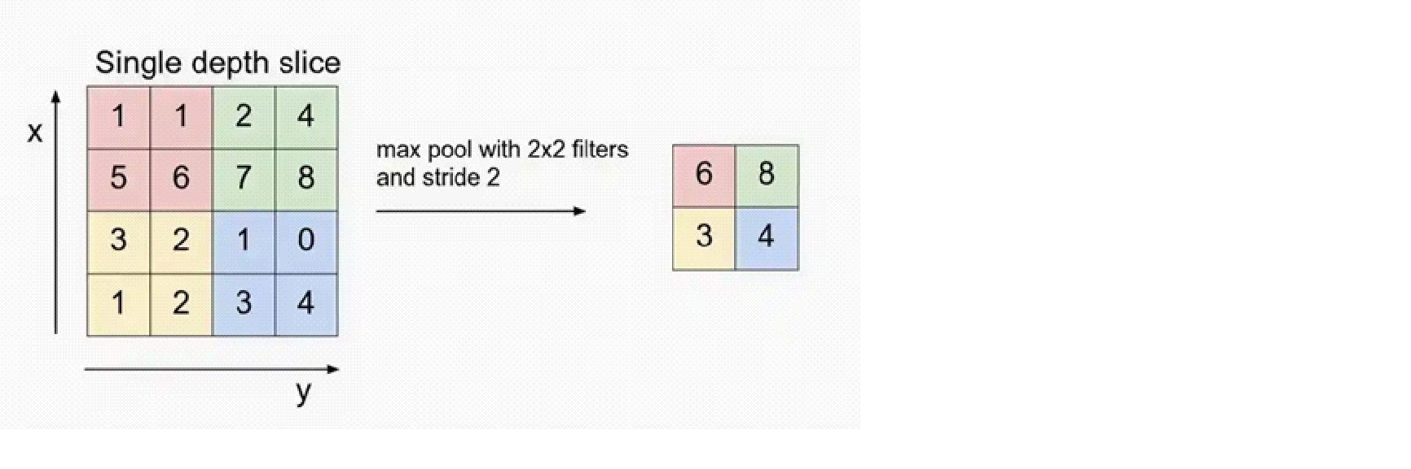

5. Flattening

Flattening converts the multi-dimensional feature maps into a one-dimensional vector after convolution and pooling. This vector is then passed to the fully connected layer for classification or regression.
z = flatten { S_{j}² | j = 1, 2, 3, 4}

Example: Flattening 16 × 16 × 12 results in a vector of size 3072 (16 × 16 × 12).

6. Fully Connected Layer

The fully connected (dense) layer performs high-level reasoning using extracted features and produces the final classification scores.

Example: The 3072-length vector is connected to neurons for classification

7. Output Layer

The output layer converts final scores into probabilities using activation functions like Sigmoid (binary classification) or Softmax (multi-class classification).

Example: For 10 classes, Softmax produces 10 probability values each representing the likelihood of a class.
Implementation Steps to demonstrate Convolutional Neural Network (illustrating how each layer processes and transforms the input image. Refer)
Step 1: Import Required Libraries: Import TensorFlow for CNN operations and Matplotlib for visualization.
Step 2: Load and Preprocess the Image: Load the image convert it to grayscale, resize it to 300×300 and normalize pixel values.

Step 3: Define Convolution Kernel: define an edge detection filter (Laplacian kernel) to extract important image features.

Step 4: Apply Convolution Layer-The convolution layer applies the filter to the image to detect edges and features.

Step 5: Apply Activation Function- e.g. ReLU removes negative values and introduces non-linearity into the network.

Step 6: Apply Max Pooling Layer- Max pooling reduces spatial dimensions while keeping important features

Step 7: Apply Flatten Layer- The flatten layer converts 2D feature maps into a 1D feature vector for fully connected layers.

Step 8: Add Fully Connected (Dense) Layer- The fully connected layer learns high-level patterns from the flattened feature vector and produces output predictions.

Different Types of CNN Models
1. LeNet: LeNet developed by Yann LeCun and his colleagues in the late 1990s was one of the first successful CNNs designed for handwritten digit recognition. It laid the foundation for modern CNNs and achieved high accuracy on the MNIST dataset which contains 70,000 images of handwritten digits (0-9).
2. AlexNet: AlexNet is a CNN architecture that was developed by Alex Krizhevsky, Ilya Sutskever and Geoffrey Hinton in 2012. It was the first CNN to win the ImageNet Large Scale Visual Recognition Challenge (ILSVRC) a major image recognition competition. It consists of several layers of convolutional and pooling layers followed by fully connected layers. The architecture includes five convolutional layers, three pooling layers and three fully connected layers.
3. Resnet: ResNets (Residual Networks) are designed for image recognition and processing tasks. They are renowned for their ability to train very deep networks without overfitting making them highly effective for complex tasks. It introduces skip connections that allow the network to learn residual functions making it easier to train deep architecture.
4. GoogleNet: GoogleNet also known as InceptionNet is renowned for achieving high accuracy in image classification while using fewer parameters and computational resources compared to other state-of-the-art CNNs. The core component of GoogleNet allows the network to learn features at different scales simultaneously to enhance performance.
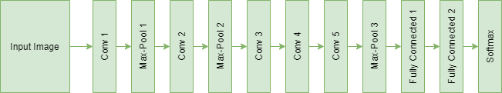
5. VGG: VGGs are developed by the Visual Geometry Group at Oxford, it uses small 3x3 convolutional filters stacked in multiple layers, creating a deep and uniform structure. Popular variants like VGG-16 and VGG-19 achieved state-of-the-art performance on the ImageNet dataset demonstrating the power of depth in CNNs.

Training a Convolutional Neural Network
CNNs are trained using a supervised learning approach. This means that the CNN is given a set of labeled training images. CNN learns to map the input images to their correct labels.
The training process for a CNN involves the following steps:
- Data Preparation: The training images are preprocessed to ensure that they are all in the same format and size.
- Loss Function: A loss function is used to measure how well the CNN is performing on the training data. The loss function is typically calculated by taking the difference between the predicted labels and the actual labels of the training images.
- Optimizer: An optimizer is used to update the weights of the CNN in order to minimize the loss function.
- Backpropagation: Backpropagation is a technique used to calculate the gradients of the loss function with respect to the weights of the CNN. The gradients are then used to update the weights of the CNN using the optimizer.

Evaluation Metrics
Efficiency of CNN can be evaluated using a variety of criteria. Among the most popular metrics are:
Accuracy: Accuracy is the percentage of test images that the CNN correctly classifies.

Precision: Precision is the percentage of test images that the CNN predicts as a particular class and that are actually of that class.

Recall: Recall is the percentage of test images that are of a particular class and that the CNN predicts as that class.

F1 Score: The F1 Score is a harmonic mean of precision and recall. It is a good metric for evaluating the performance of a CNN on classes that are imbalanced.

Problem Definition:
To implement CNN AlexNet architecture for object classification. (https://www.geeksforgeeks.org/machine-learning/ml-getting-started-with-alexnet/)

Details of data set used: CIFAR-10 Dataset
API/Function used:
cifar10.load_data() – Loads dataset
Sequential() – Creates model
Conv2D() – Extracts features
MaxPooling2D() – Reduces dimensions
Flatten() – Converts to 1D
Dense() – Fully connected layer
compile() – Sets optimizer & loss
fit() – Trains model
evaluate() – Tests model
plot(), show() – Displays graphs

Results:
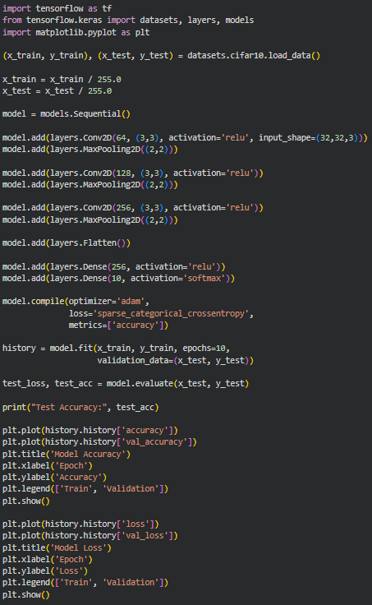

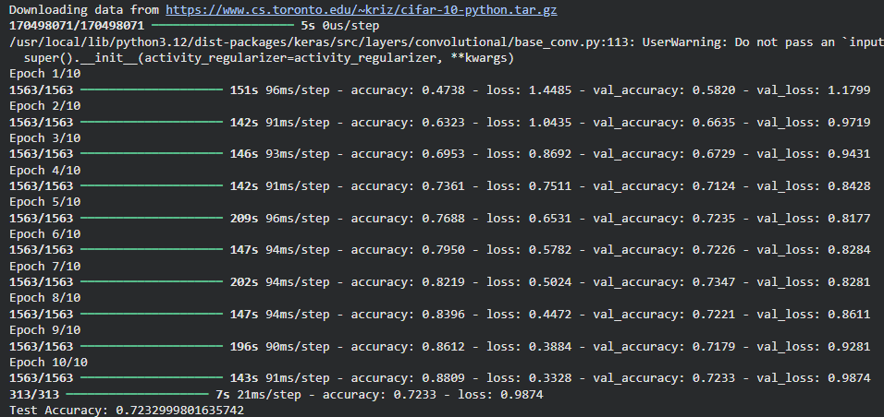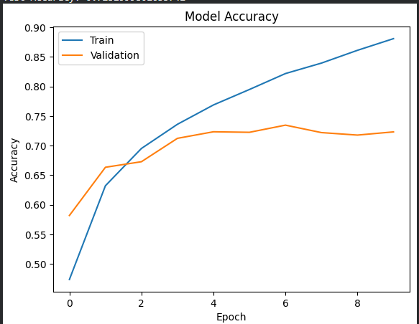
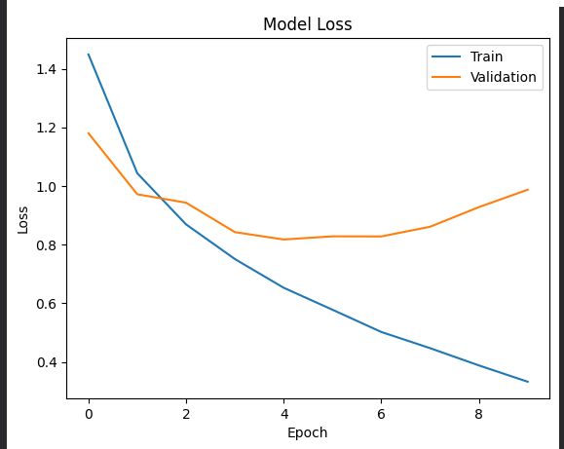
Conclusion:
In this experiment, a Convolutional Neural Network (CNN) based on the AlexNet architecture was implemented for image classification using the CIFAR-10 dataset. The model successfully extracted spatial features using convolutional layers, reduced dimensionality through pooling, and performed classification using fully connected layers. Activation functions introduced non-linearity, enabling the model to learn complex patterns. The performance was evaluated using metrics such as accuracy, precision, recall, and F1-score. This experiment demonstrates that CNNs are highly effective for image-based tasks due to their ability to automatically learn hierarchical feature representations.

Post Lab:
- Explain what is the significance of splitting the data into training and validation and number of epochs in the training of CNN model.
Splitting data into training and validation sets is essential to evaluate how well the CNN generalizes to unseen data. The training set is used to learn model parameters, while the validation set is used to monitor performance during training and detect overfitting. Without a validation set, the model may perform well on training data but fail on new data. The number of epochs refers to how many times the model passes through the entire training dataset. Too few epochs lead to underfitting, where the model does not learn enough patterns, while too many epochs may cause overfitting, where the model memorizes training data. Hence, selecting an optimal number of epochs ensures a balance between learning and generalization.

- Explain any one light weight CNN model suitable for mobile based application.
One popular lightweight CNN model is MobileNet. It is designed specifically for mobile and embedded devices with limited computational resources. MobileNet uses depthwise separable convolutions instead of standard convolutions, which significantly reduces the number of parameters and computational cost. Despite being efficient, it maintains good accuracy for tasks such as image classification, object detection, and face recognition. This makes MobileNet suitable for real-time applications on smartphones and edge devices.

